1. **Are the HTML tags and elements the same thing?**

:- HTML tags are building blocks of HTML page. HTML elements are componets that are used in HTML page. HTML tags usually exist in pairs consisting of a starting and an ending teg. However, some tags do not have a closing teg.

1. **What are tags and attributes in HTML?**

:- HTML tags are used to hold the HTML element. HTML element holds the content. HTML attributes are used to describe the characteristic of an HTML element in detail.HTML tags start with < and ends with> whatever written within a HTML tag are HTML elements.

1. **What are void elements in HTML? With Example.**

:- A void element is an element whose contents under any circumstances. Void elements can have attributes. The following is complete list of the void elements in HTML : area , base , br , col , command , embed , hr , img , input , keygen , link , meta , param , source , track , wbr.

Example :- <br> <hr> <img> <link> <meta>

1. **What are HTML Entities? With Example.**

:- An HTML entities is a piece of text ( “string” ) that begins with an ampersand ( & ) and ends with a semicolon ( ; ). HTML entities are frequently used to display reserved characters ( which would otherwise be interpreted as HTML cod), and invisible characters ( lick non-breaking spaces )

Example:- 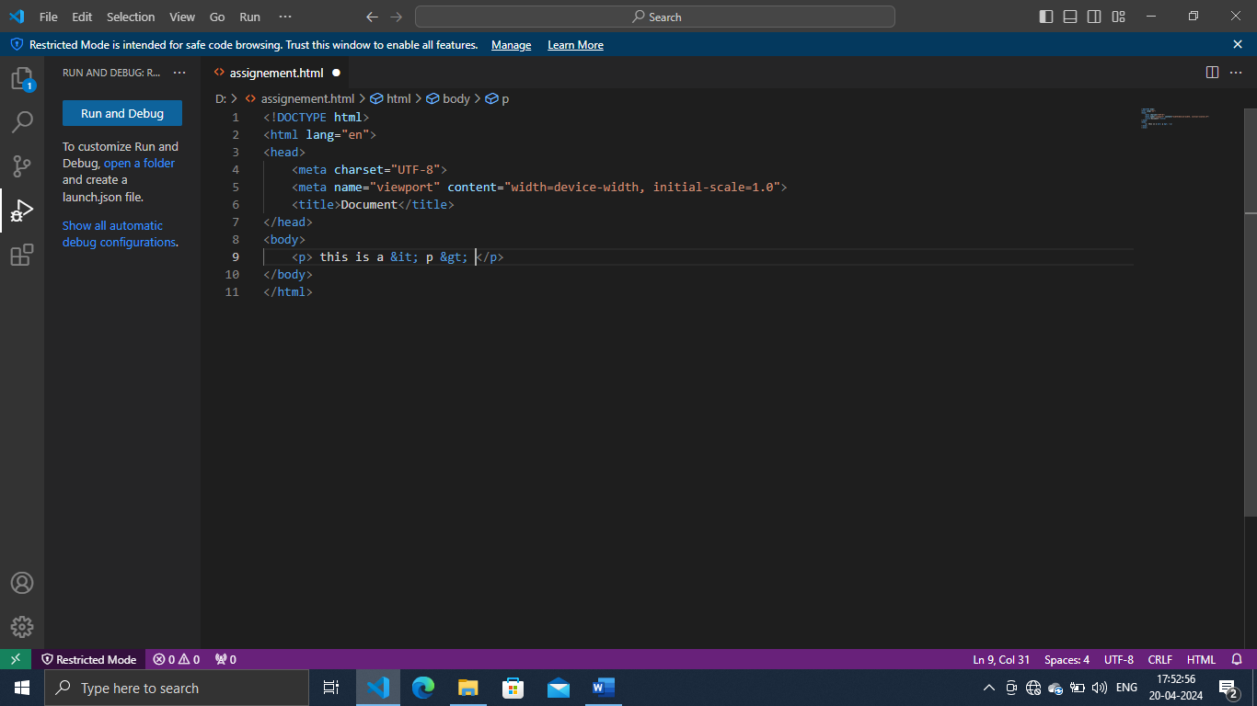

1. **What are different types of lists in HTML? With Example.**

:- 1 unordered

An unordered list defines a list of items in which the order of the items dose not. Or in other words, an unordered list teg is used to create an unordered

2 ordered

An ordered list has an in inherent order. This type of list used when the sequence and ich item needs to be numbered

3 definition list

Definition list are lists having each list item with a title as well as a description. There can also be multiple description for each of the list item.

Example:- 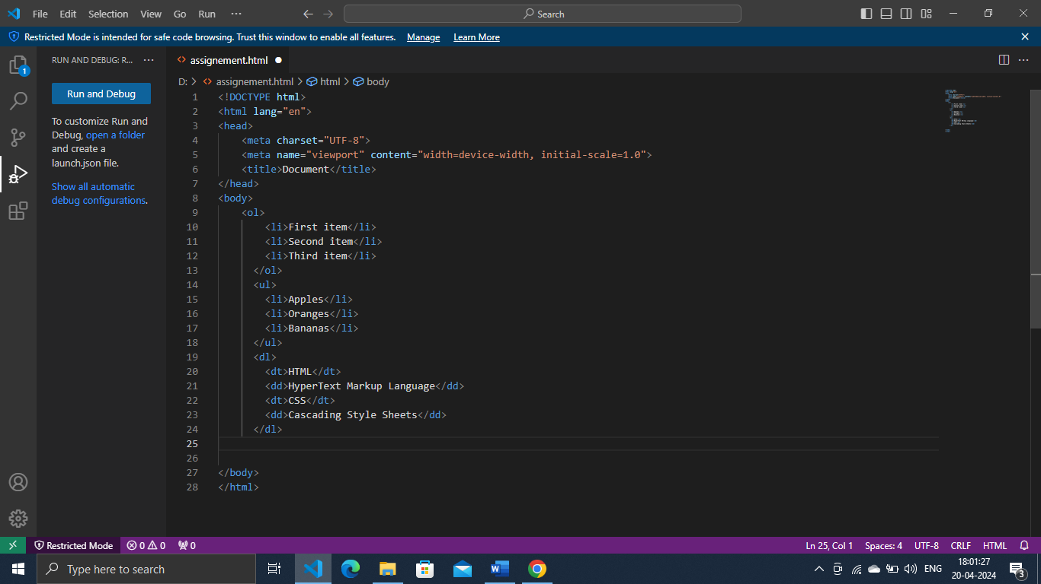

1. **What is the ‘class’ attribute in HTML? With Example.**

:- The class attribute specifies one or more class names for an element. The class attribute is mostly used to point to a class in style sheet. However, it can also be used by a javascript ( via the HTML dom ) to make changes to HTML elements with a specified class.

Example:- 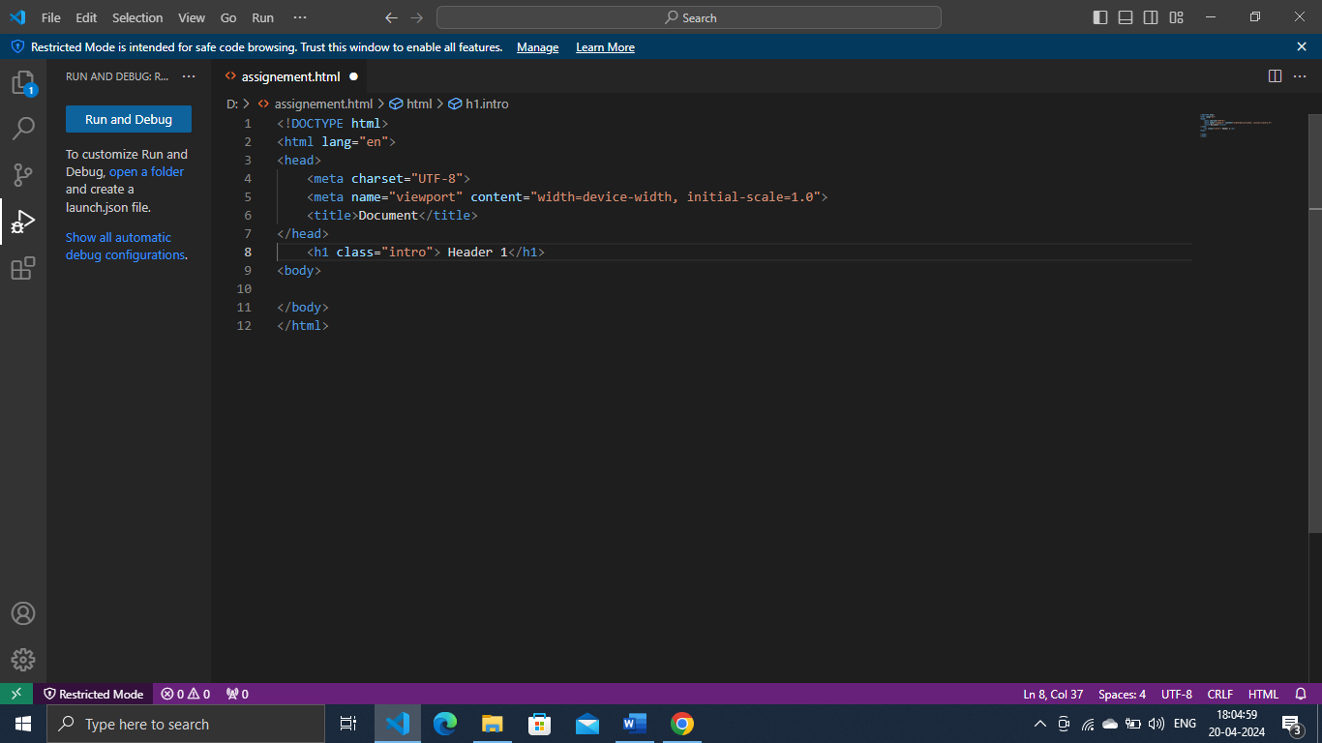

1. **What is the difference between the ‘id’ attribute and the ‘class’ attribute of HTML elements? With Example.**

**:-** A class name can be used by multiple time HTML elements, and an ID name must only be used by one HTML elements.

**Example:-** 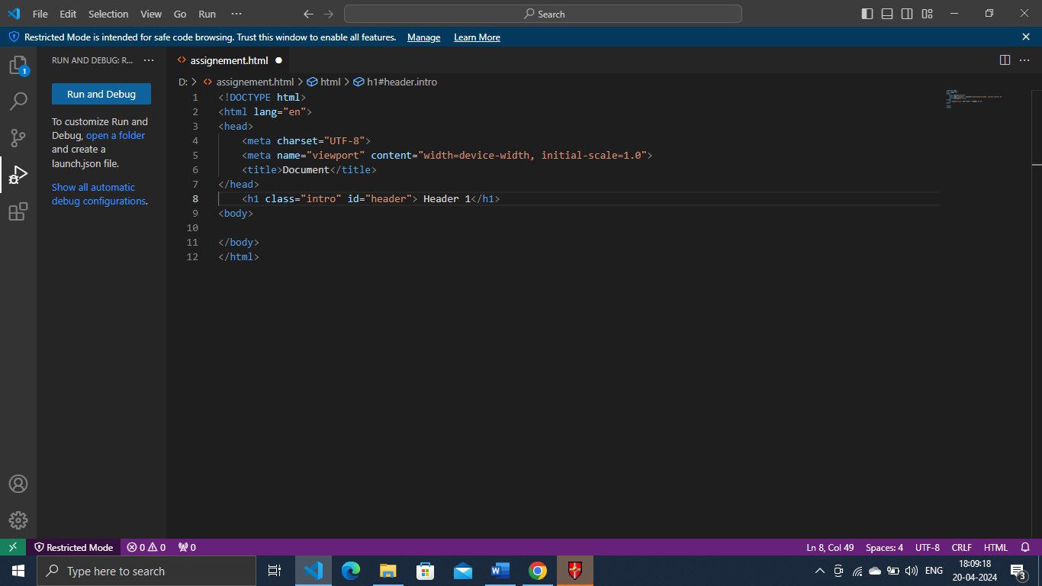

1. **What are the various formatting tags in HTML?**

:- you may apply three different character formatting style in word documents; font, font size, bold, italic, underline, strikethrough, subscript, superscript, font colour, and highlight colour in individual character formats.

1. **How is Cell Padding different from Cell Spacing? With Example.**

**:-** cellpadding basically defines the space present between a table cell’s border and the content present in it. Cellspacing basically defines the space present between individual adjacent cells. One can create it using the teg of HTML < table > but is sets the type attribute to cellpadding.

**Example:-** 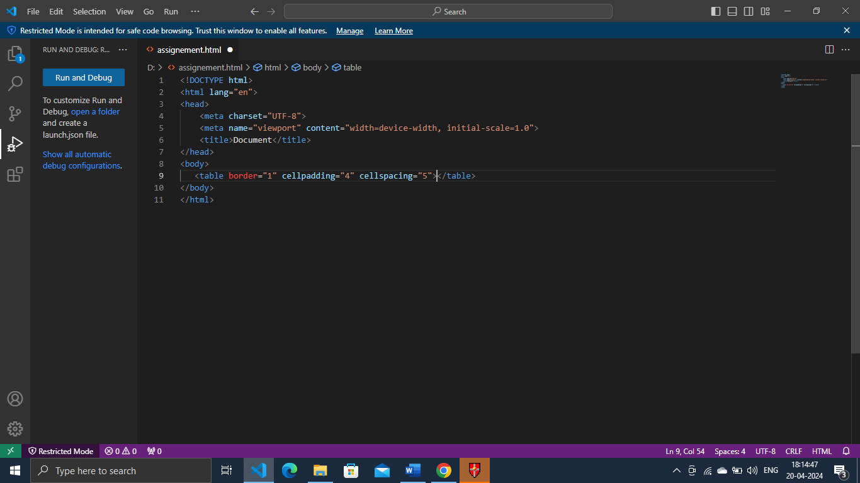

1. **How can we club two or more rows or columns into a single row or column in an HTML table? With Example.**

**:- to merge two or more row cells, use the rowspan attribute. If you went to combine the first two cells in the first two cells in the first column, you can use the first tag. The number represents how many cells to use ( marge ) for the tag.**

**Example:-** 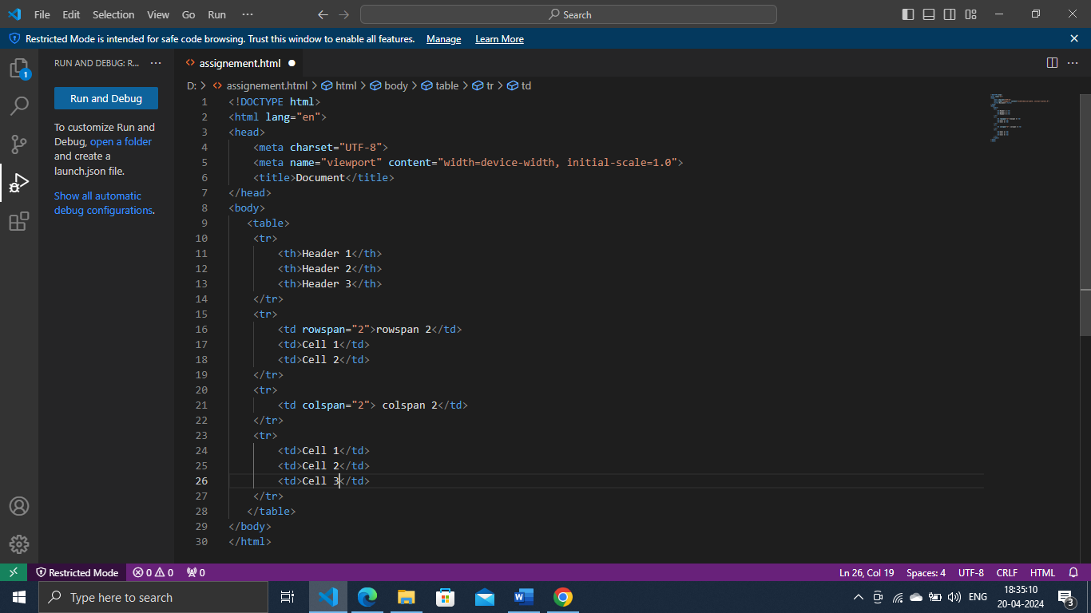

1. **What is the difference between a block-level element and an inline element?**

:- inline elements occupy only sufficient width required. Block element occupy the full width irrespective of their sufficiency. Inline elements don’t start in a new line. Block element always start in a line.

1. **How to create a Hyperlink in HTML? With Example.**

:- first state with your anchor tag:

1 <a href=”http;//www.yourhomepage.com”> </a> now, add the anchor text people will click to go your link:

Example:- 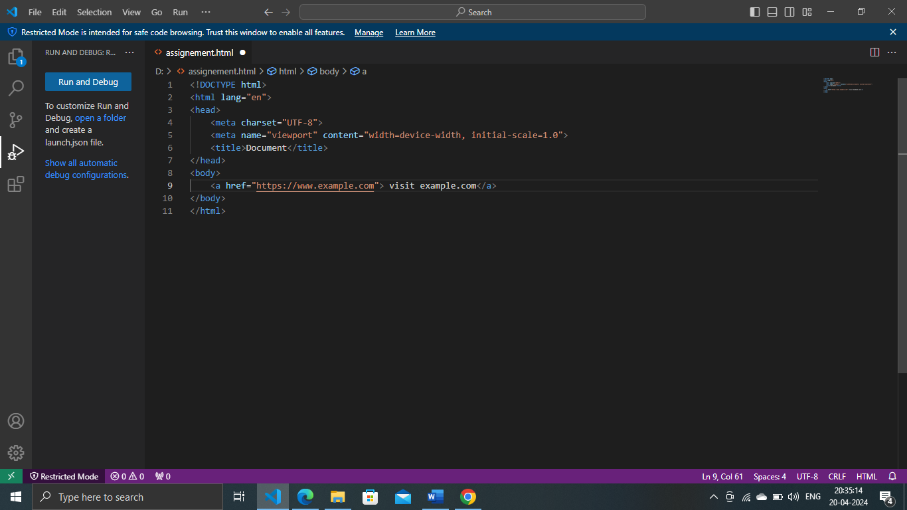

1. **What is the use of an iframe tag? With Example.**

:- the most common use of an iframe is to load content from another site within the page. The child site can load it’s own content and cookies, so sites may allow it where they don’t direct hotlinking content. Using an iframe is the accepted way to embed a you tube video or google maps content**.**

**Example:-** 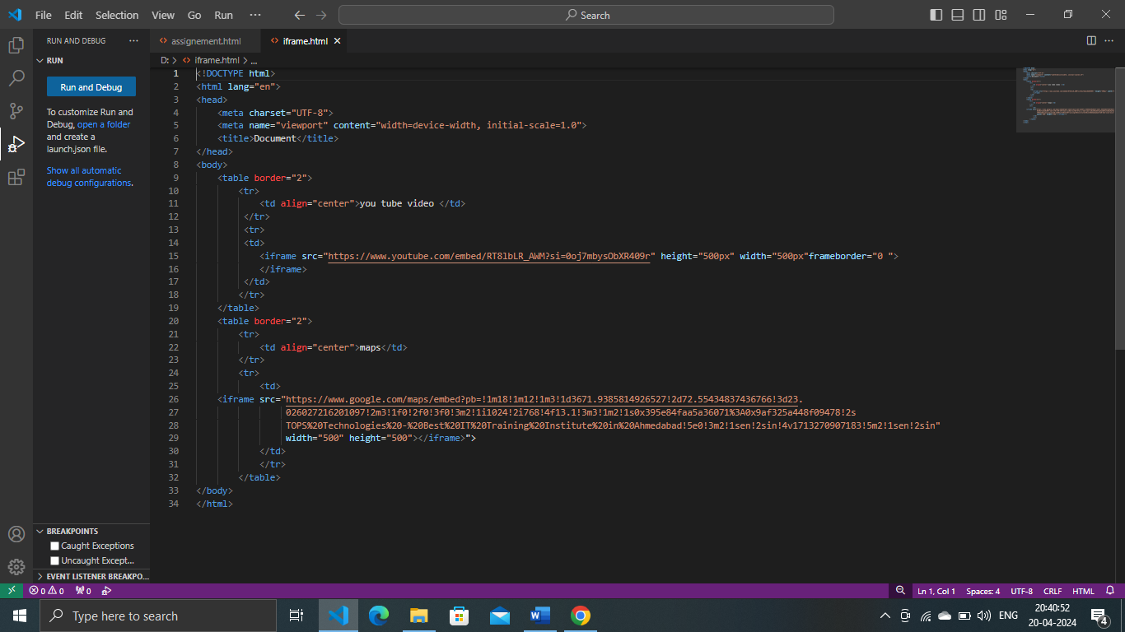

1. **What is the use of a span tag? Explain with example?**

:- common uses of a span tag include changing the style or color of a part of the text, highlighting a section of text and inserting icon or small graphics inline with text.

Example:- 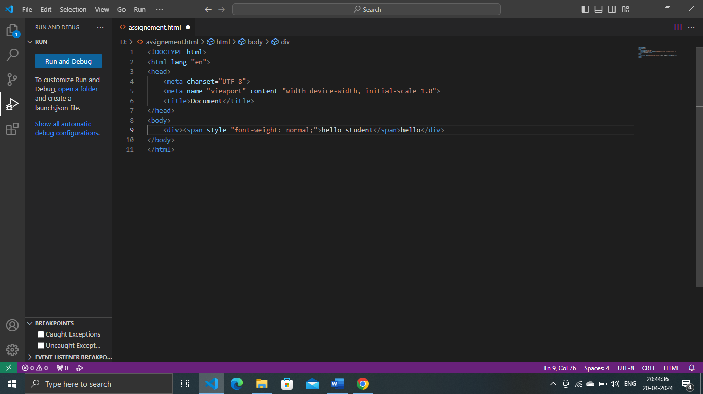

1. **How to insert a picture into a background image of a web page? With Example.**

:- 1 open the HTML file in text editor

2 within the staring <body> tag in your HTML file, type <body background=” “>

3 give the path of the image we went to add. ( example, <body background=”C :usersaanshuman. Singh downloadsinfoedge.jpg”>

Example:- 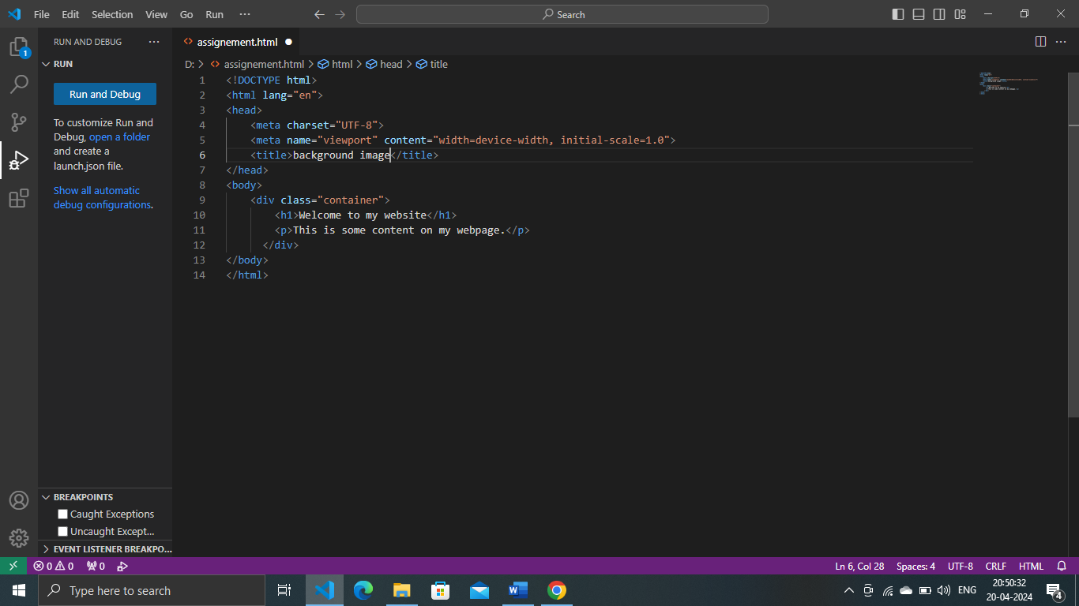

1. **How are active links different from normal links?**

:- normal link are links which are there on the page and have not been clicked yet. Active link are those link, which have just been clicked at that instant.

1. **What are the different tags to separate sections of text?**

:- we separate a section of text in html using the below text

* <br> tag – it is used to separate the line of text. It brakes the current line and shifts the flow of the text to a new line.
* <p> teg – this tag is used to write a paragraph of text.
* <blockquote< tag – this tag is used to define large quoted section.

1. **What is SVG?**

:- svg files are vector-based-built from a complex mathematical network of line, dots, shapes, algorrithms. They can expend to any size without losing their resolution.

1. **What is difference between HTML and XHTML?**

**:-** HTML and XHTML are both markup languages used foe creating and displaying web pages. The main difference between them is the syntax and structure; HTML is more lenient in its syntax, while XHTML has a more strict syntax and follows XML rules.

1. **What are logical and physical tags in HTML?**

:- physical and logical tags are used in html for better visibility and understanding of the text by the user on the web page. However, both tags differ from each other as suggested by their names.

Logical tags : logical tags are used in html to display the text according to the logical styles.